Dashboard Instructions

Link - <https://public.tableau.com/profile/jared.pickering#!/vizhome/HWA3DataFusion/DivorceMurderMap?publish=yes>

1. Our first visualization on the dashboard is the “Divorce / Murder trend” which looks at the average Divorce rate and the average Murder rate over the years. This does show that the divorce rate closely follows the murder rate.
2. The second visualization on the dashboard is the “Marriage / Murder trend by state”. This visualization will show a dual line chart of the state that you chose on the top right drop down (see below). In this visualization, the Average murder rate correlates with the Average number of murders. 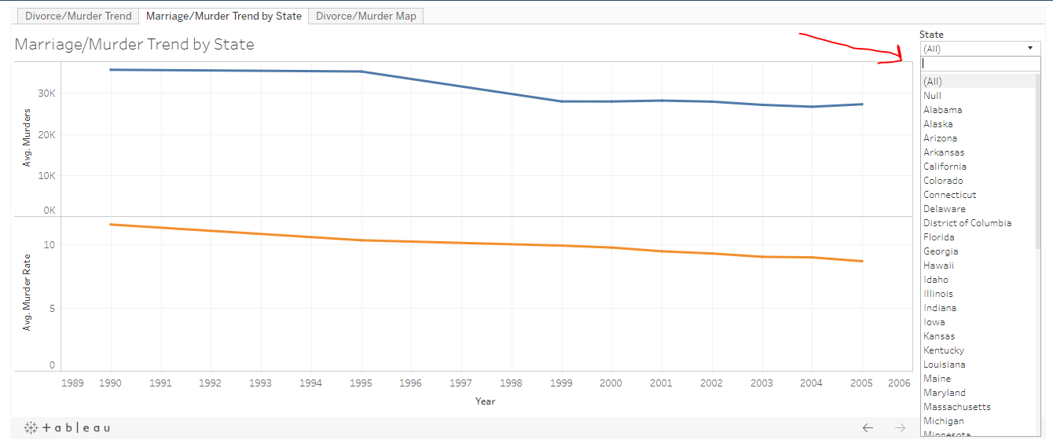
3. Lastly, our third visualization on the dashboard is the “Murder totals and Divorce rate by state” that is visualized on a map. We came to the conclusion that it was important for us to utilize the map visualization since State was a key column between the Marriage/Divorce and Crime datasets.